AWS CSV Upload and Processing System

Process

I first created an lambdas folder in that subfolders for my 3 lambda function codes

1. api-handler

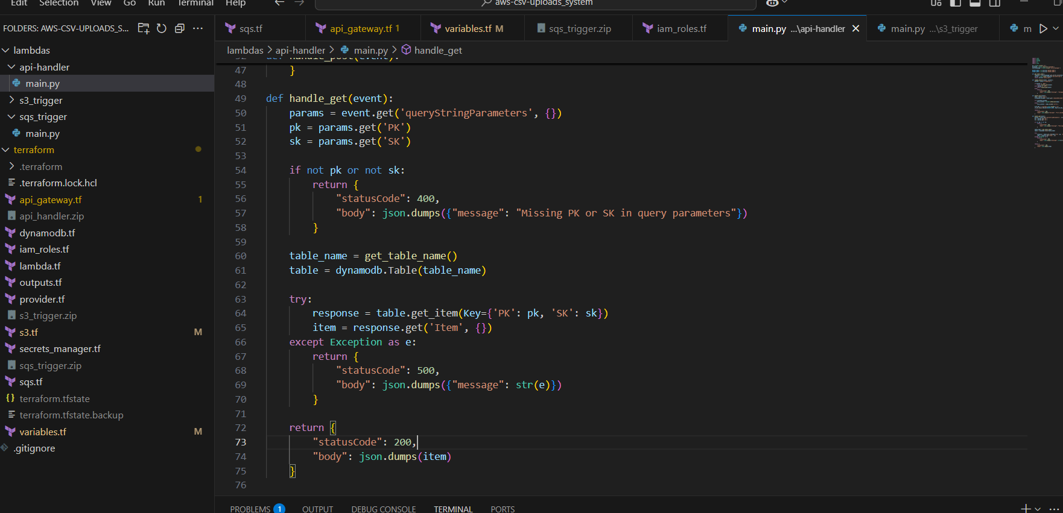

1. s3-trigger

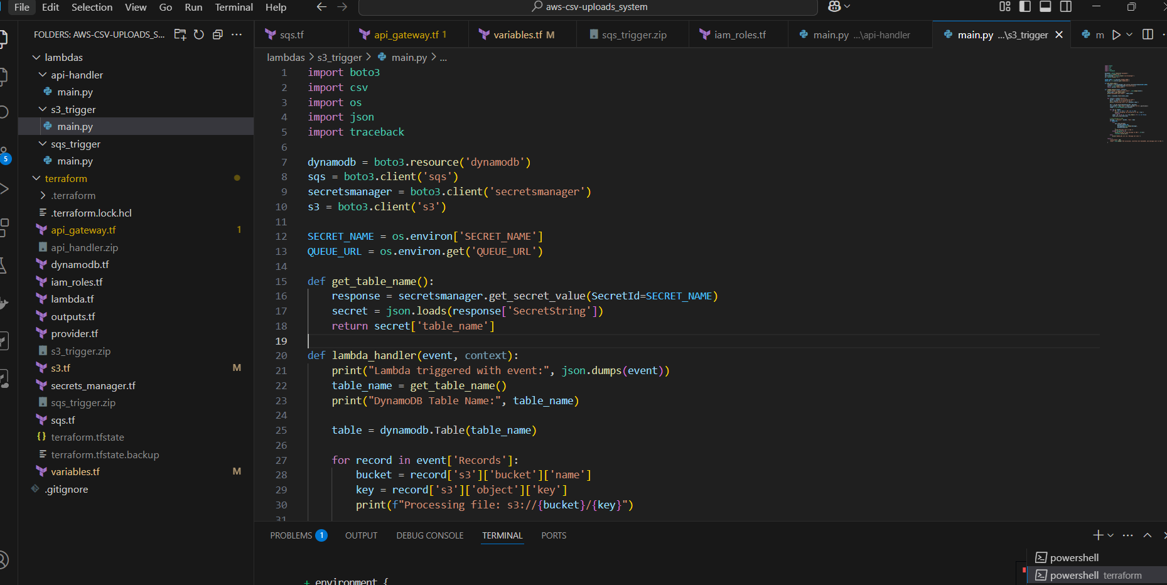

1. sqs-trigger

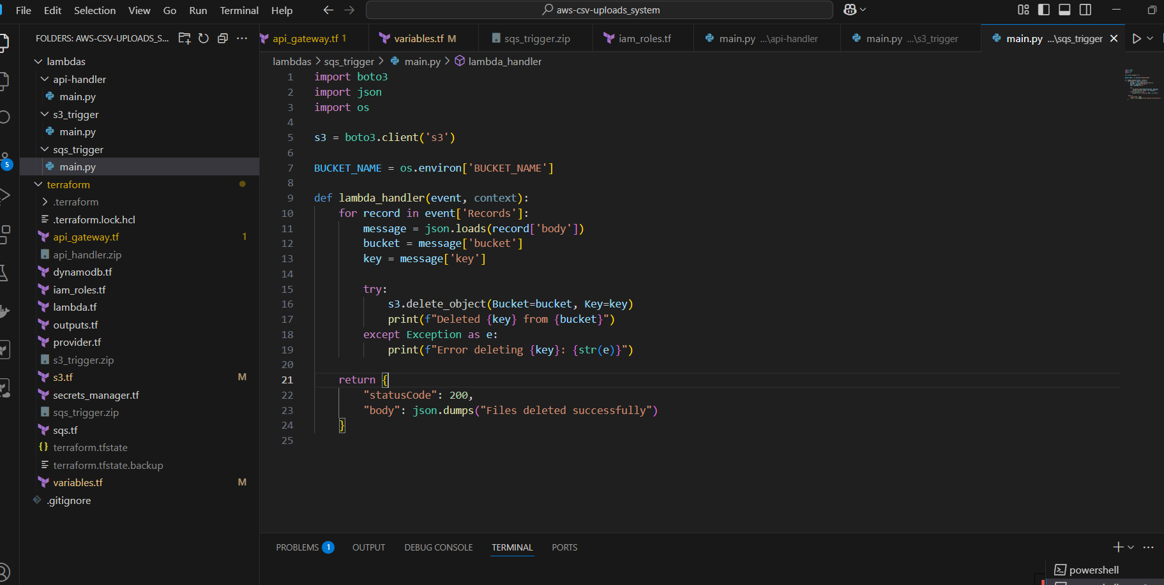

And then I zip these files to get into my lambda function code in the terraform directory

Then I have created an .tf files of the services that included in the tasks.  
Posting an Screenshot of the files code and its automatic resources created in the AWS Console:

1. Provider.tf

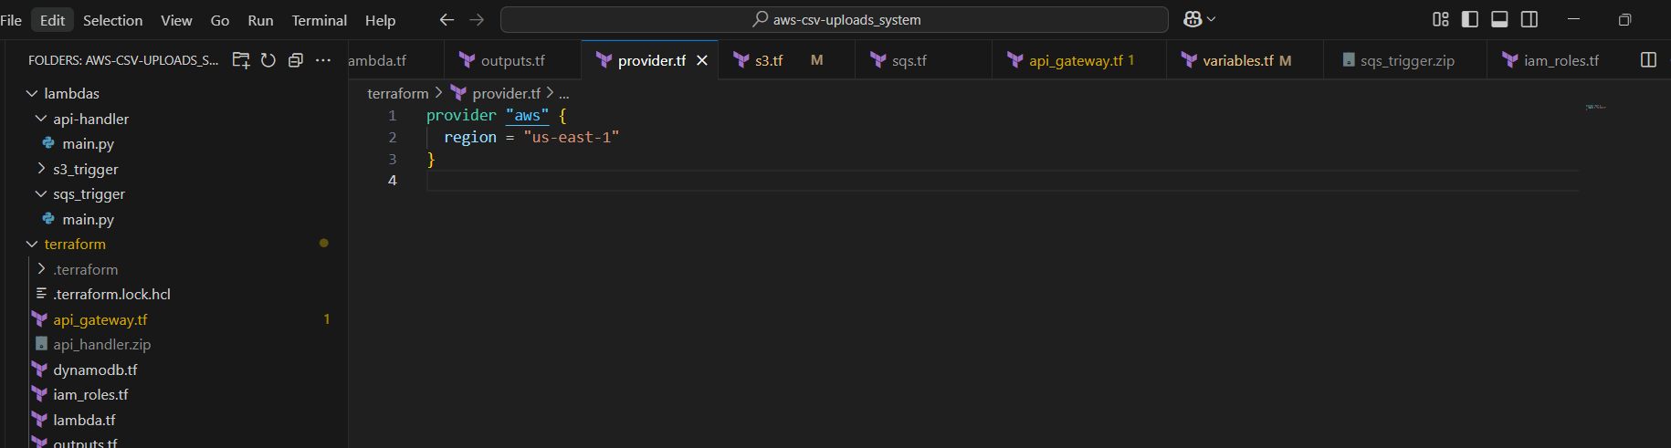

2) variables.tf  
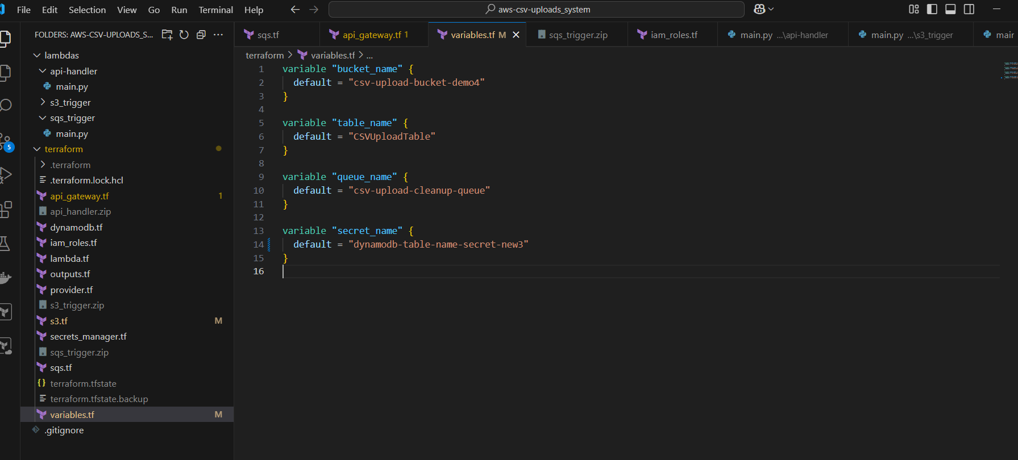

3)Lambda.tf  
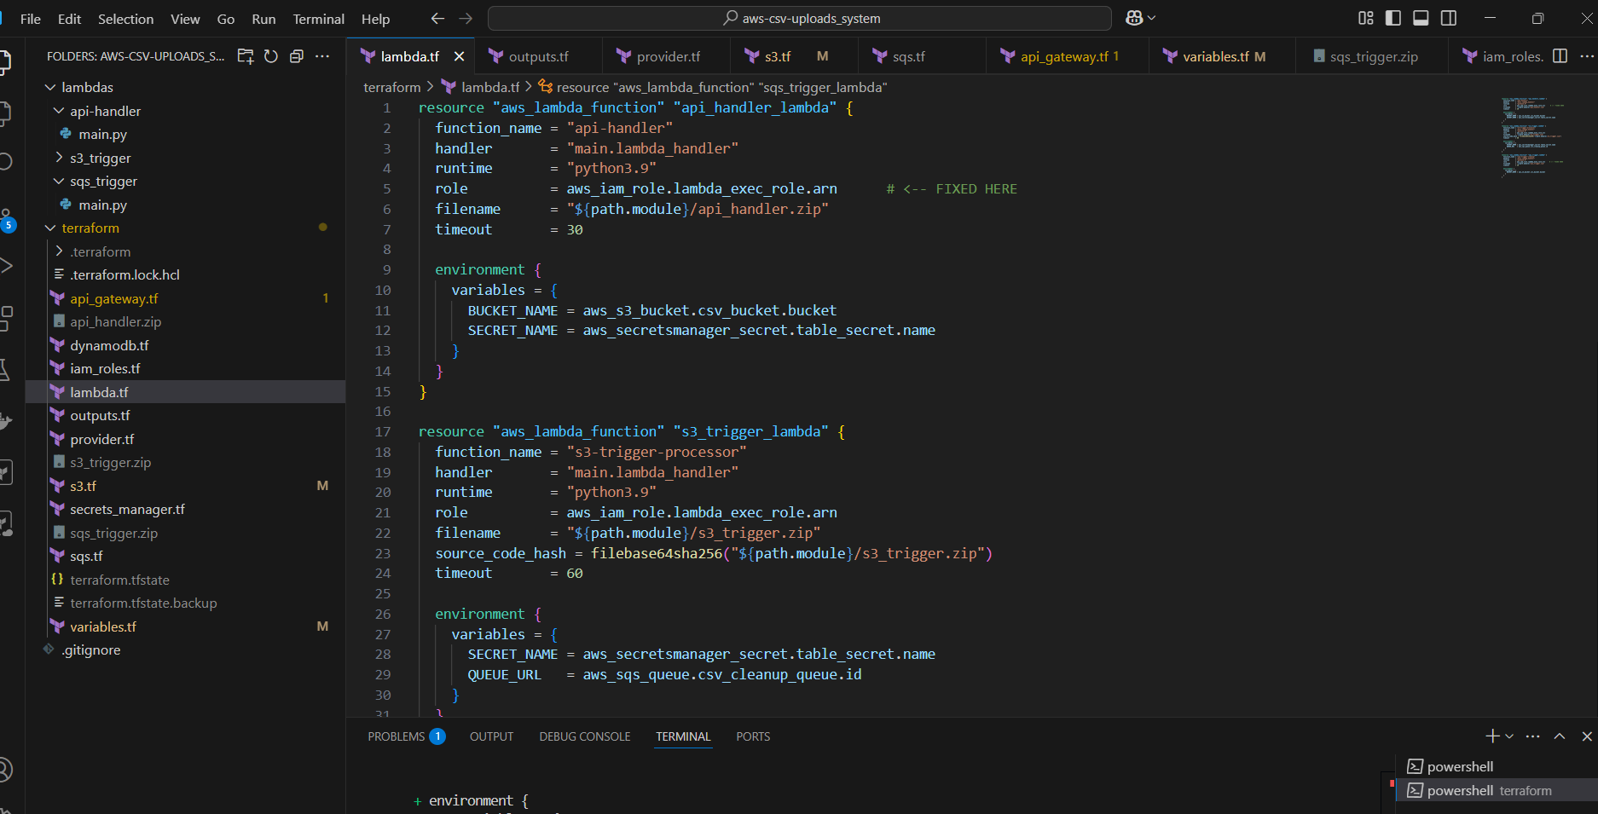

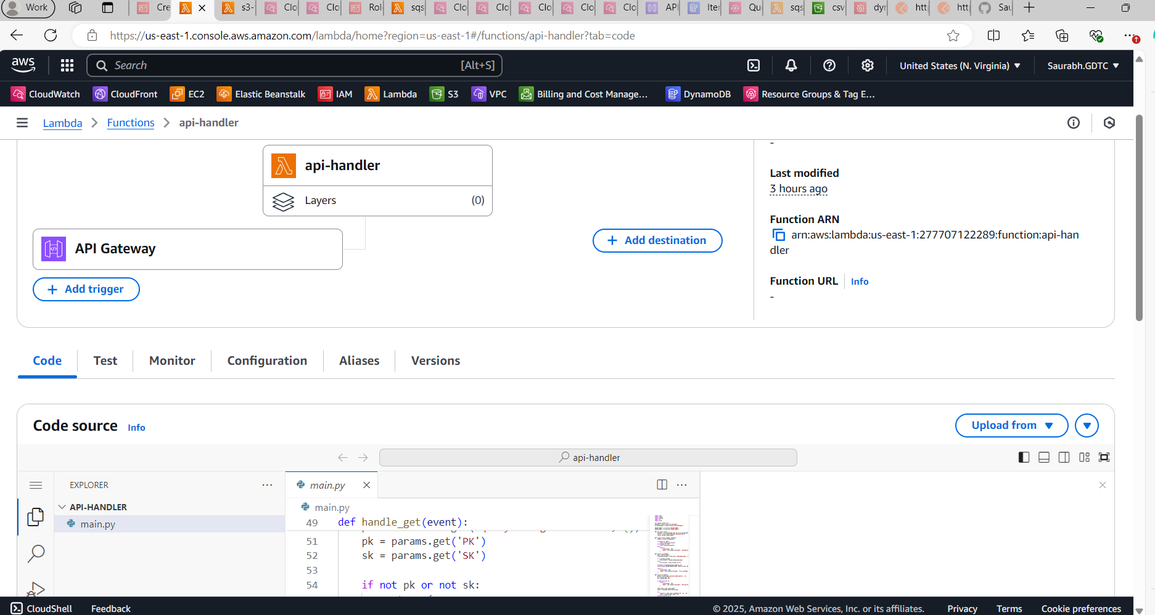

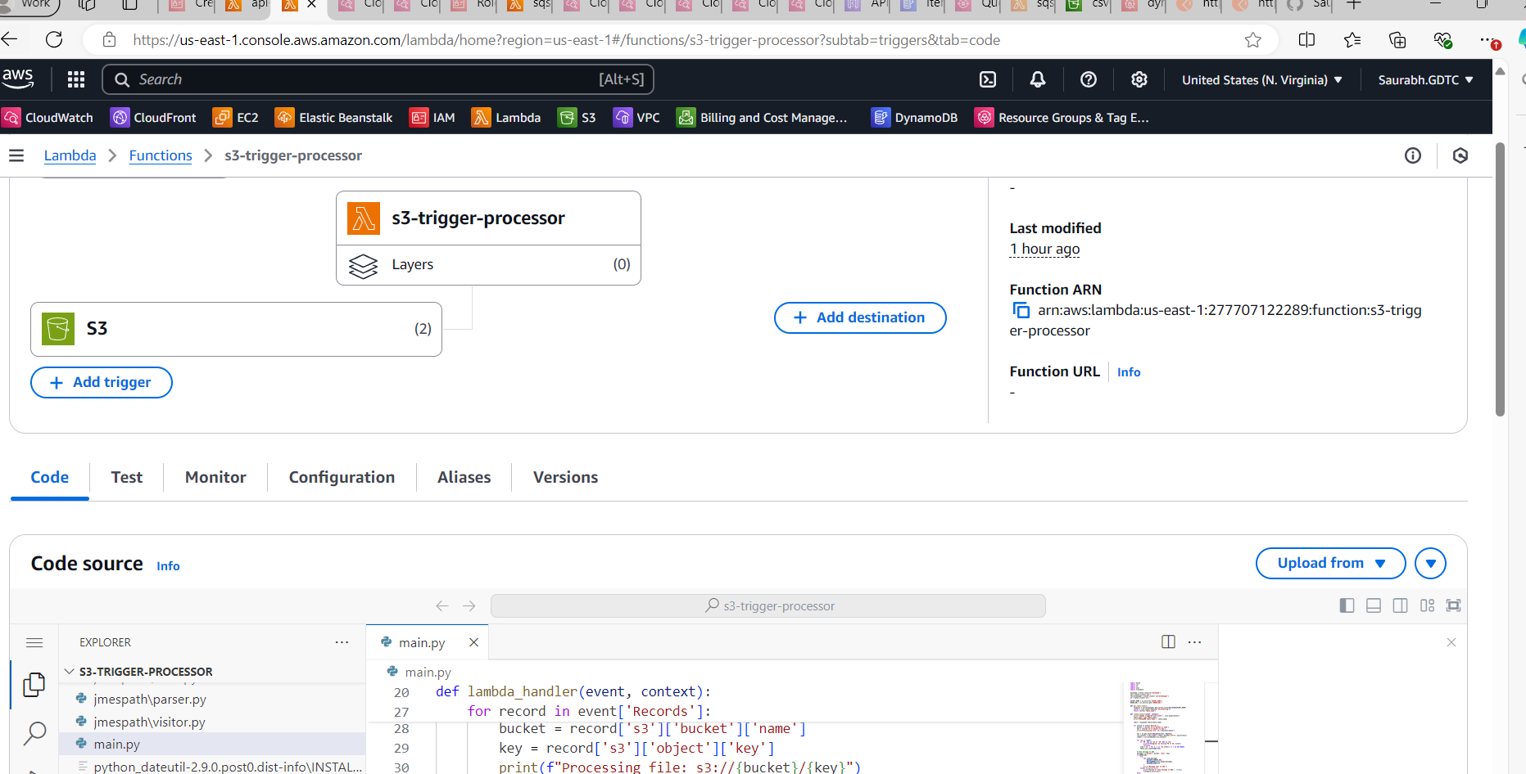

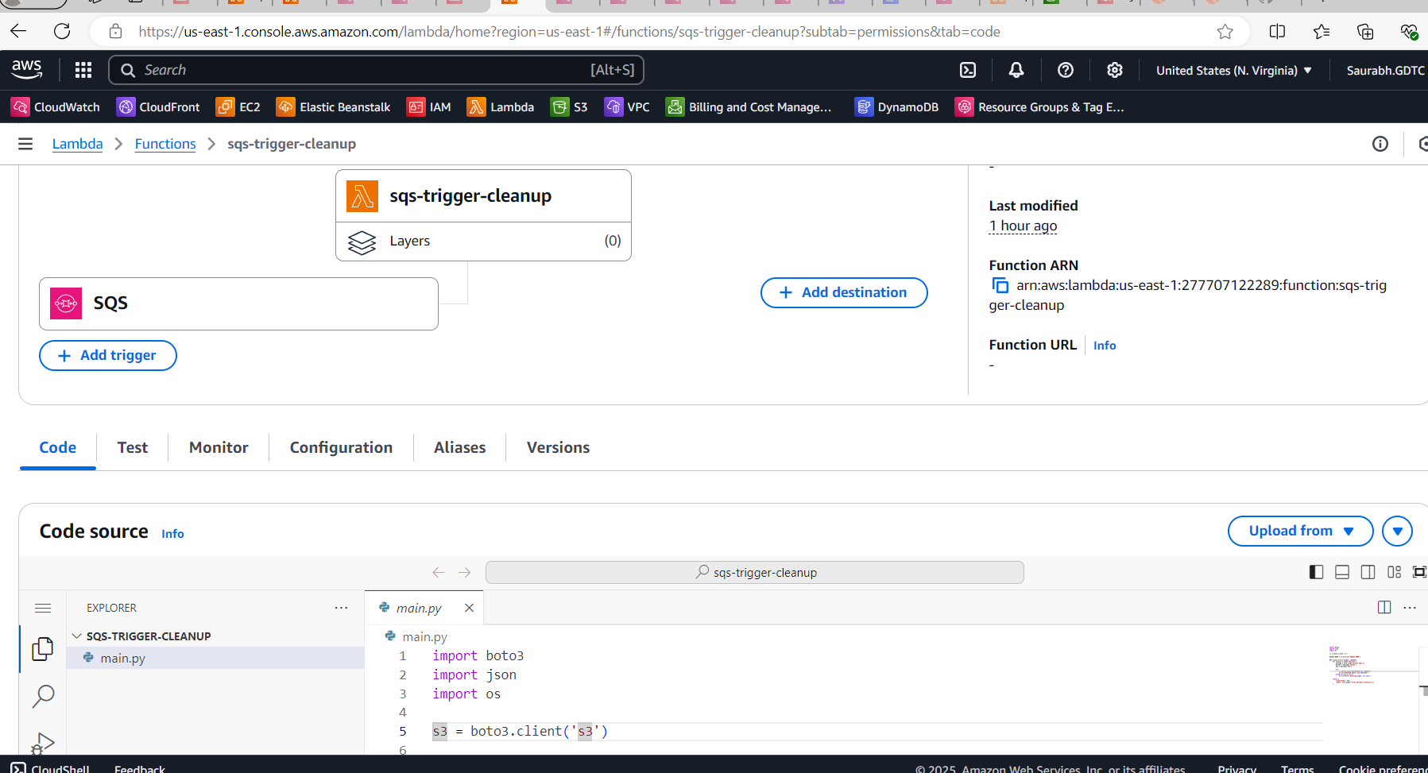

4) iam_roles.tf

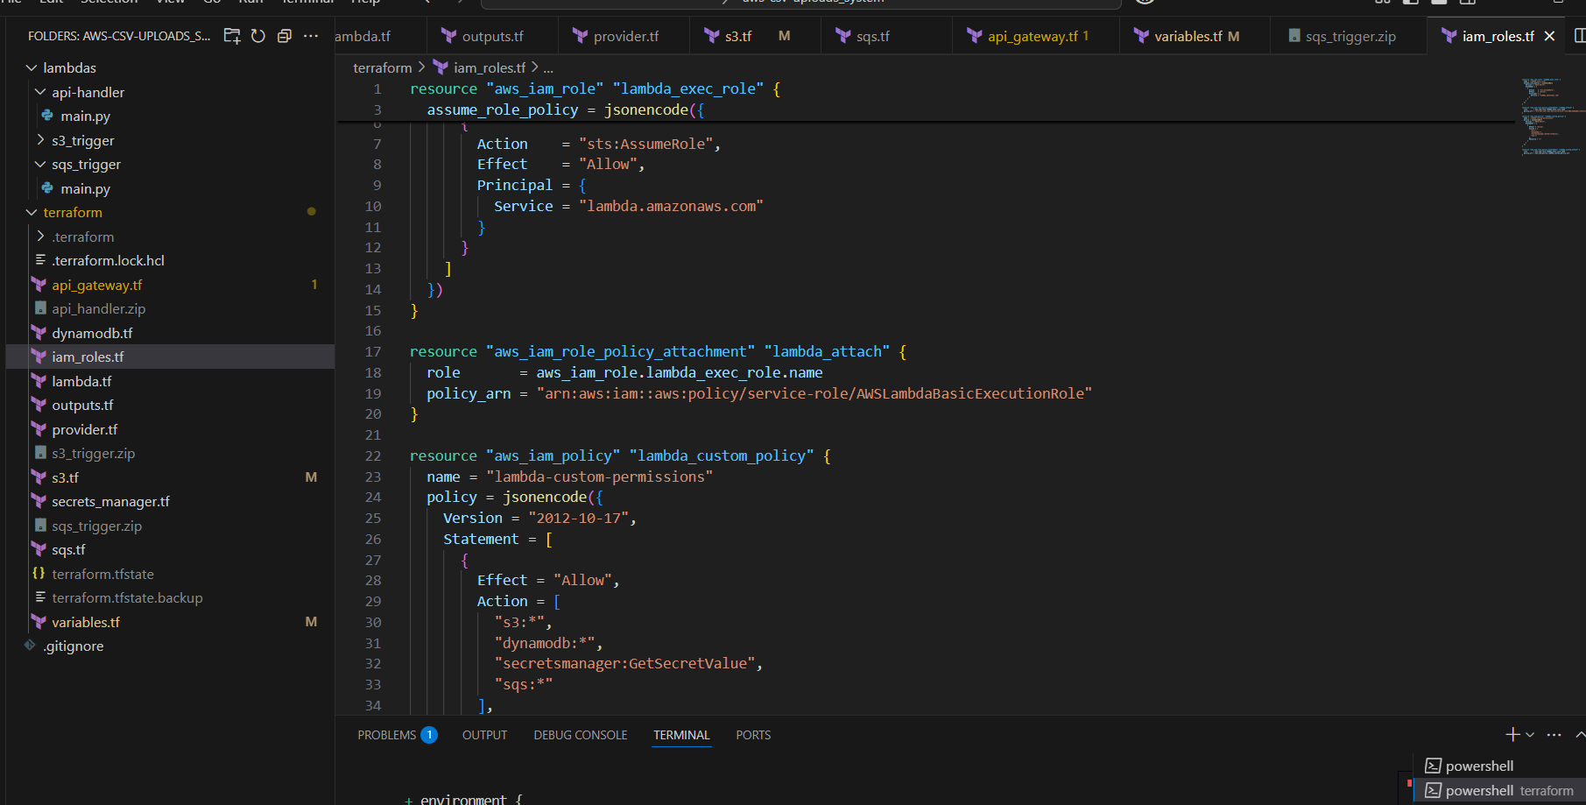

5) dynamobd.tf

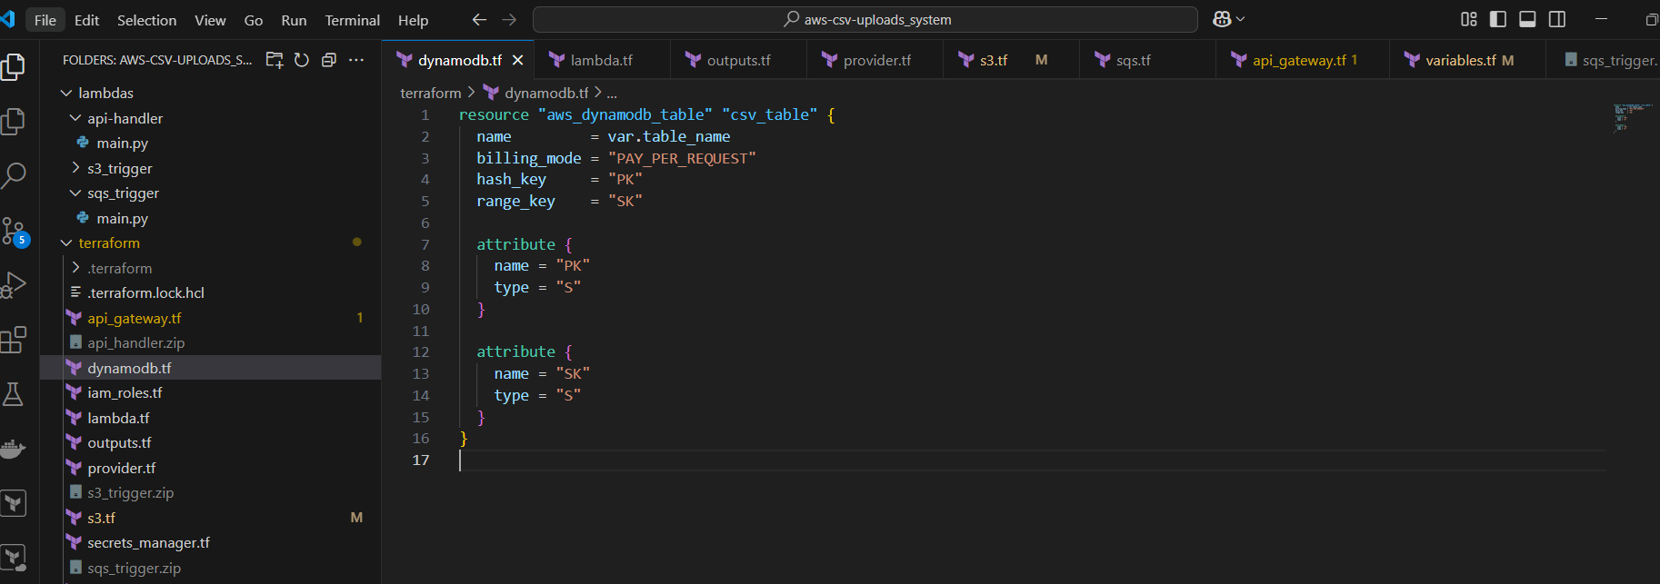

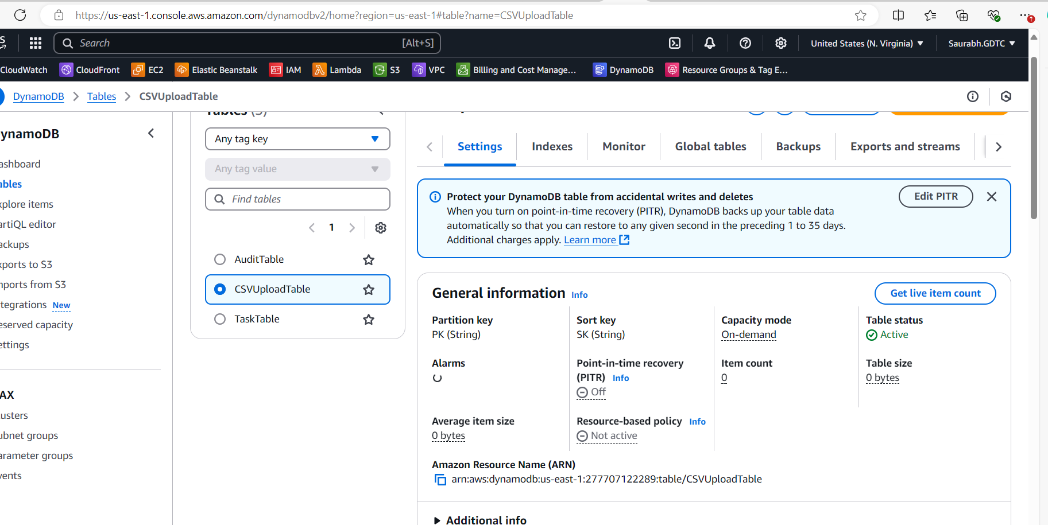

6) api_gateway.tf

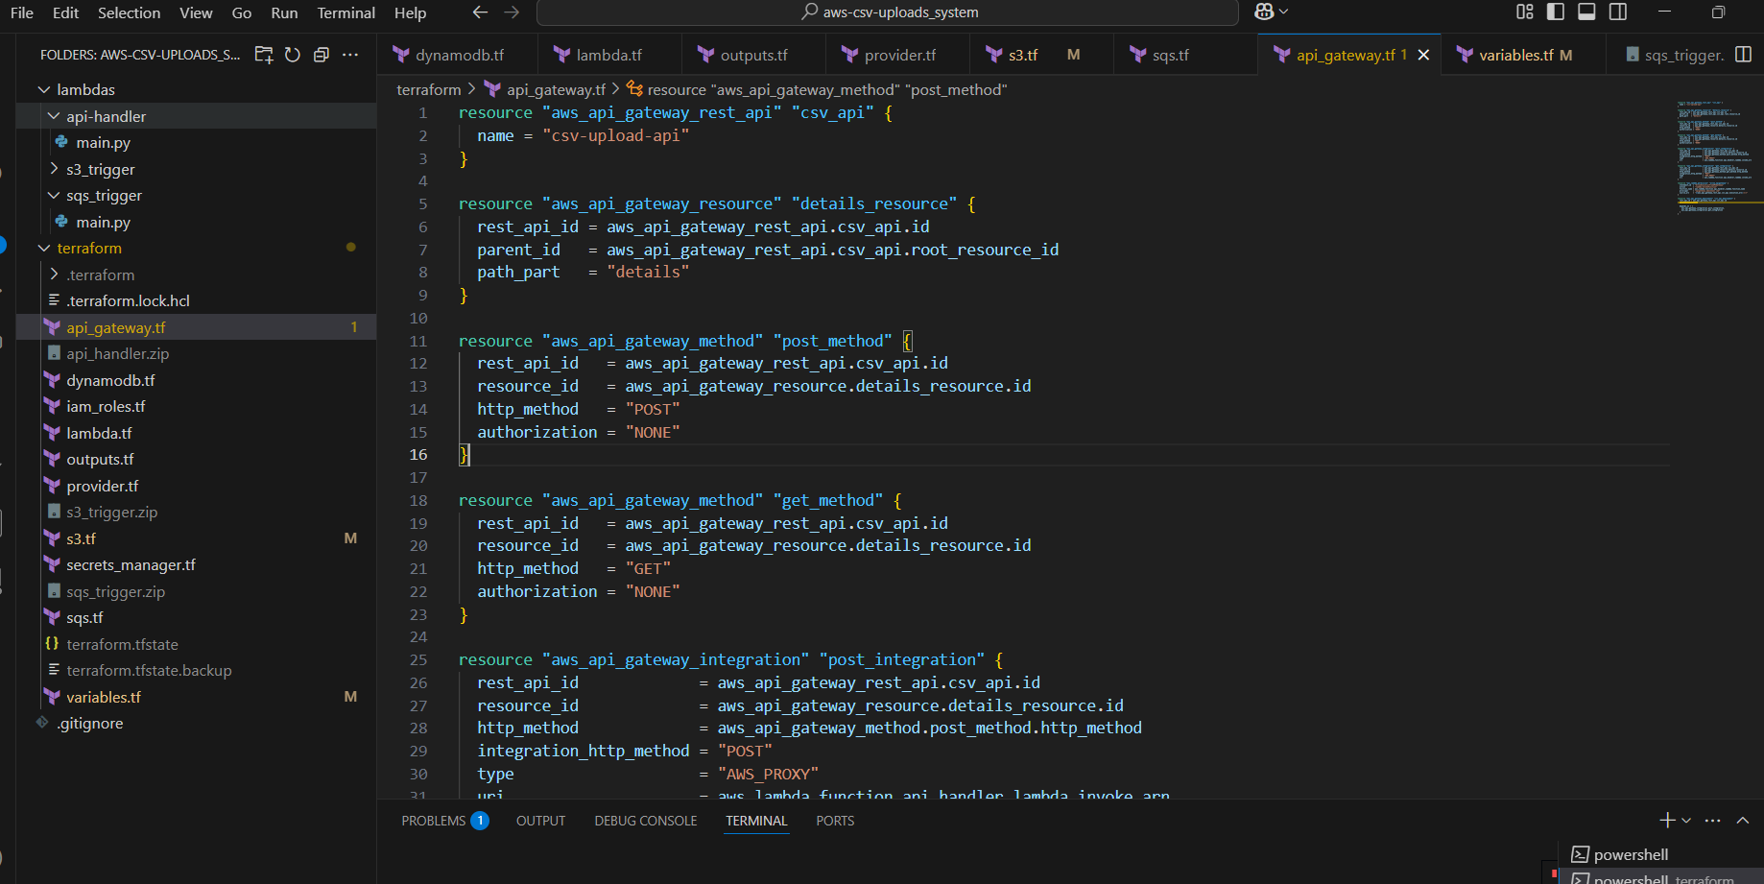

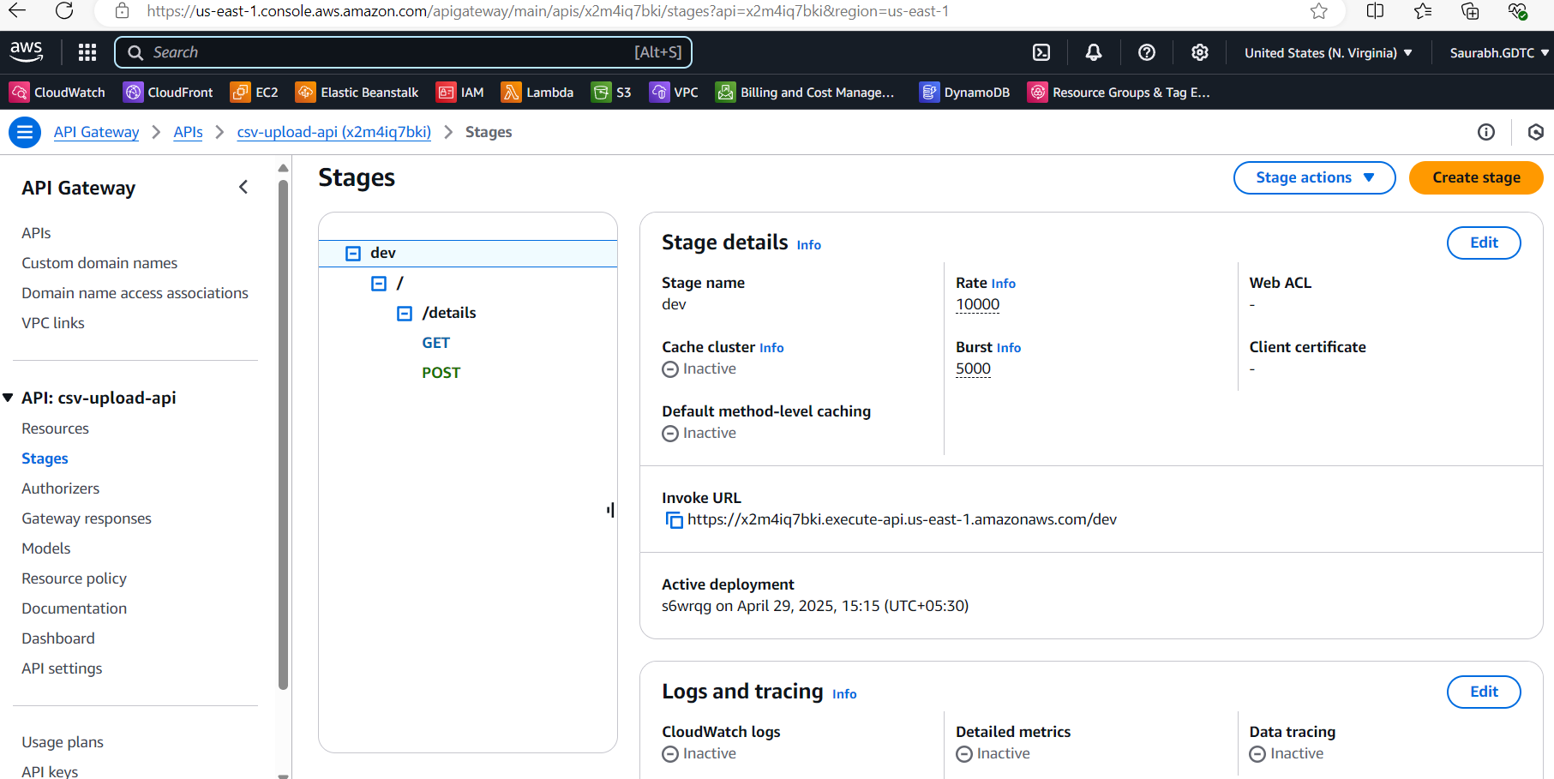

7) s3_trigger.tf

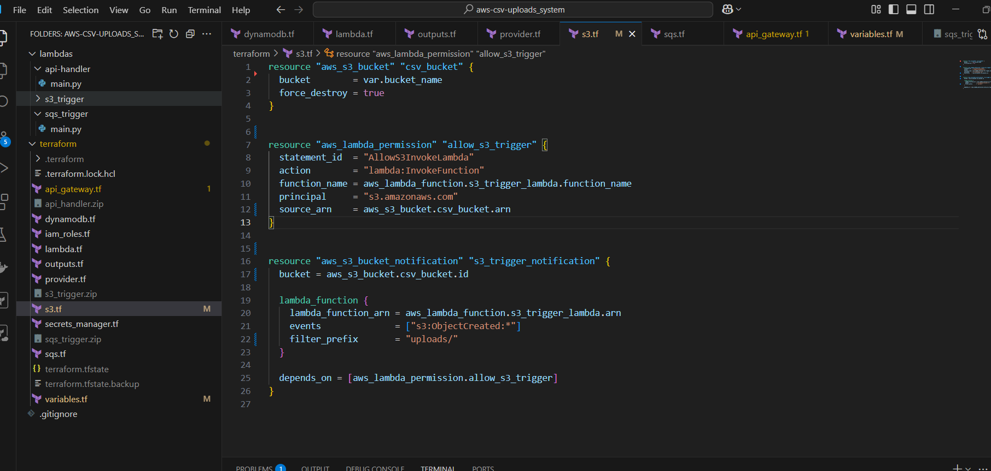

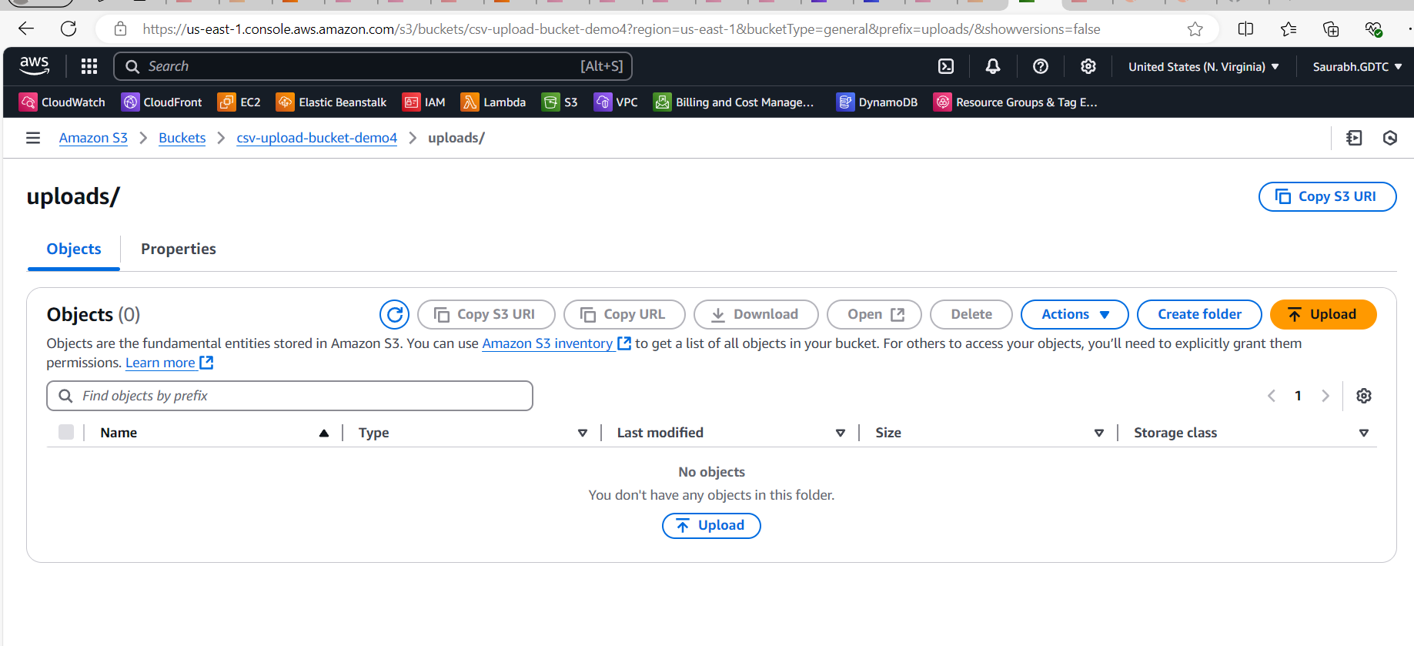

8) secrets_manager.tf

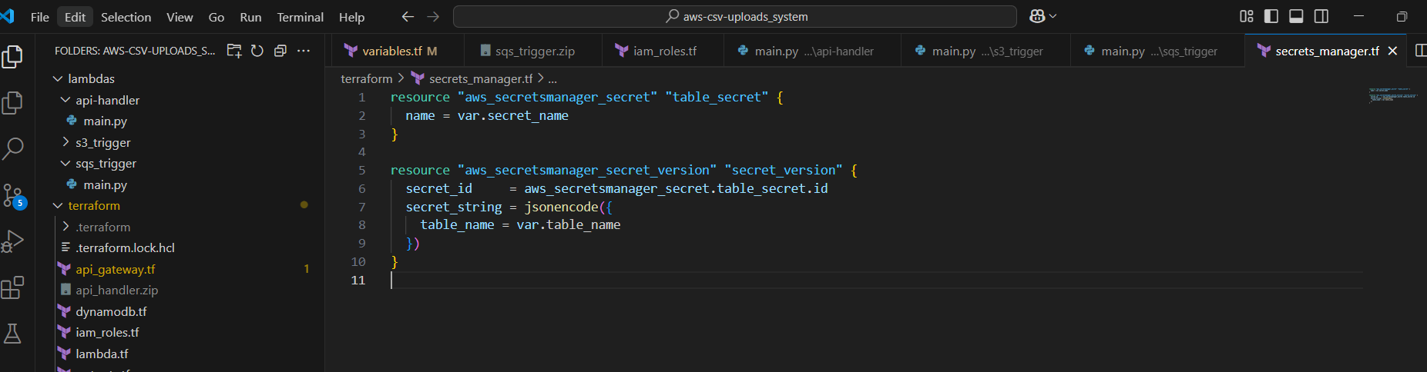

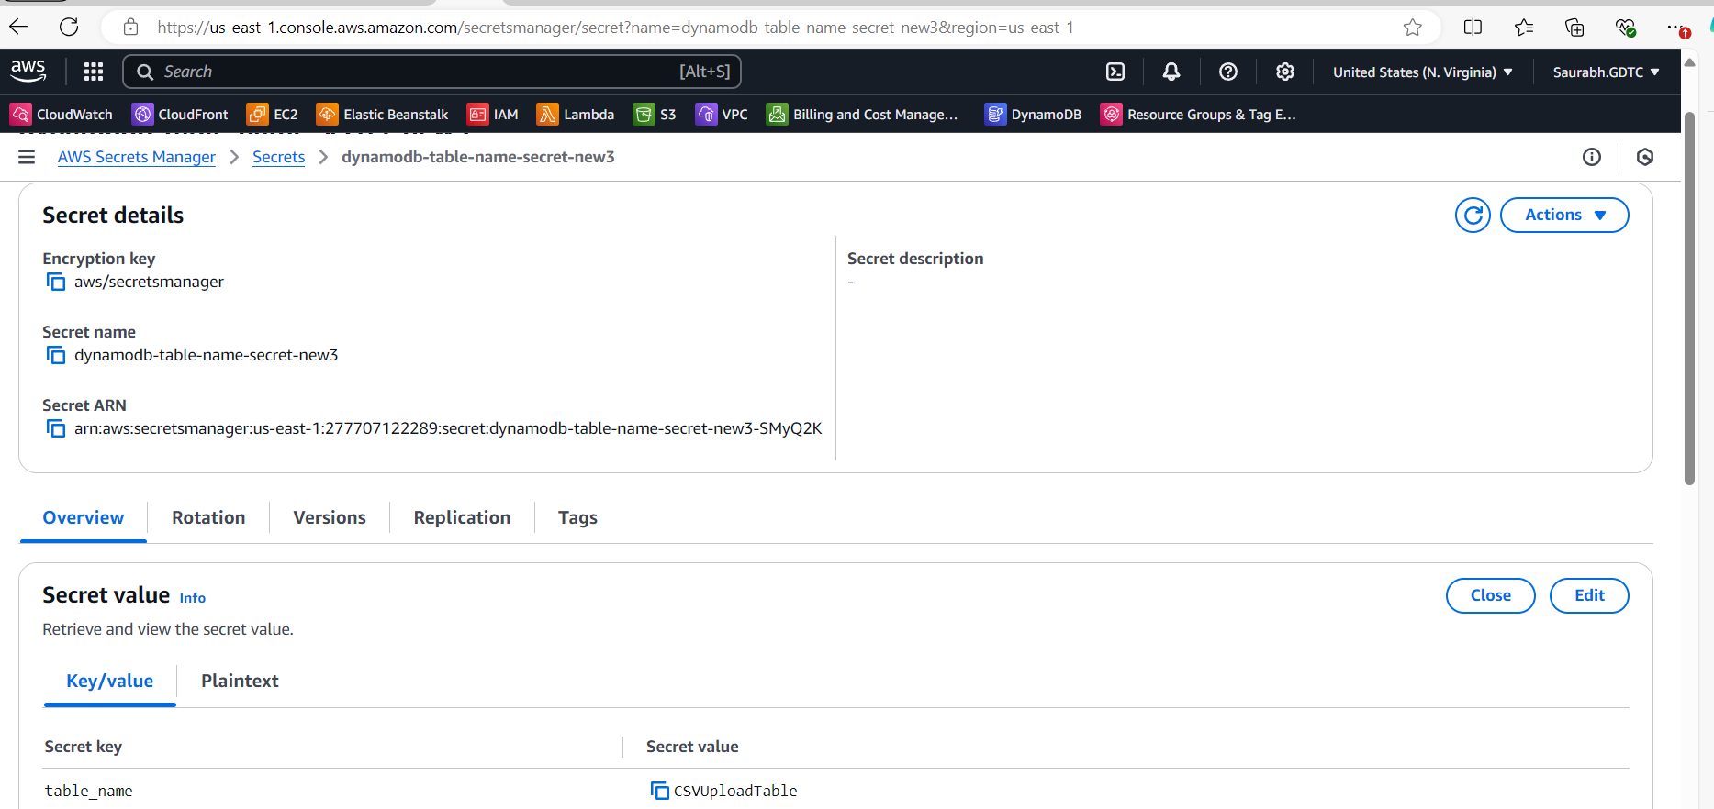

9) sqs_queue

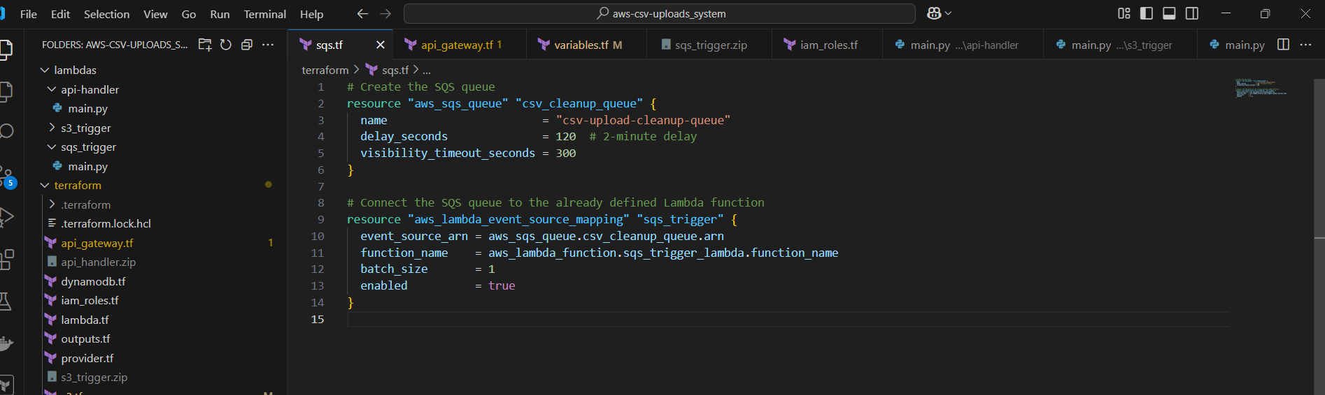

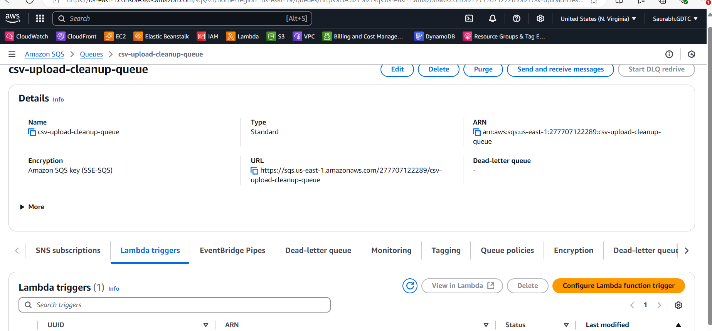

The Outputs:

**Client → POST /details → API Gateway → Lambda → S3 → Trigger Lambda → DynamoDB & SQS → Delete File**

1 ) Sending the file of 50 records through Postman it will first get stored in my S3 Bucket through my first lambda function which is api-handler

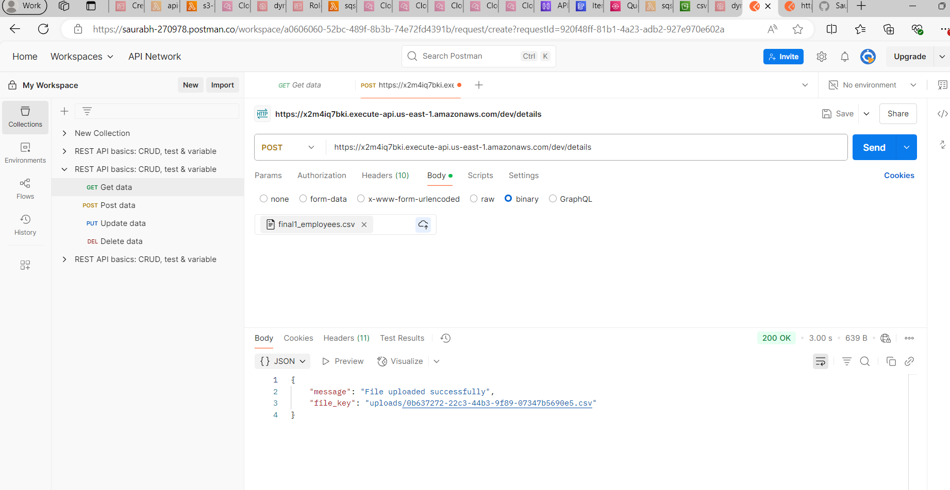

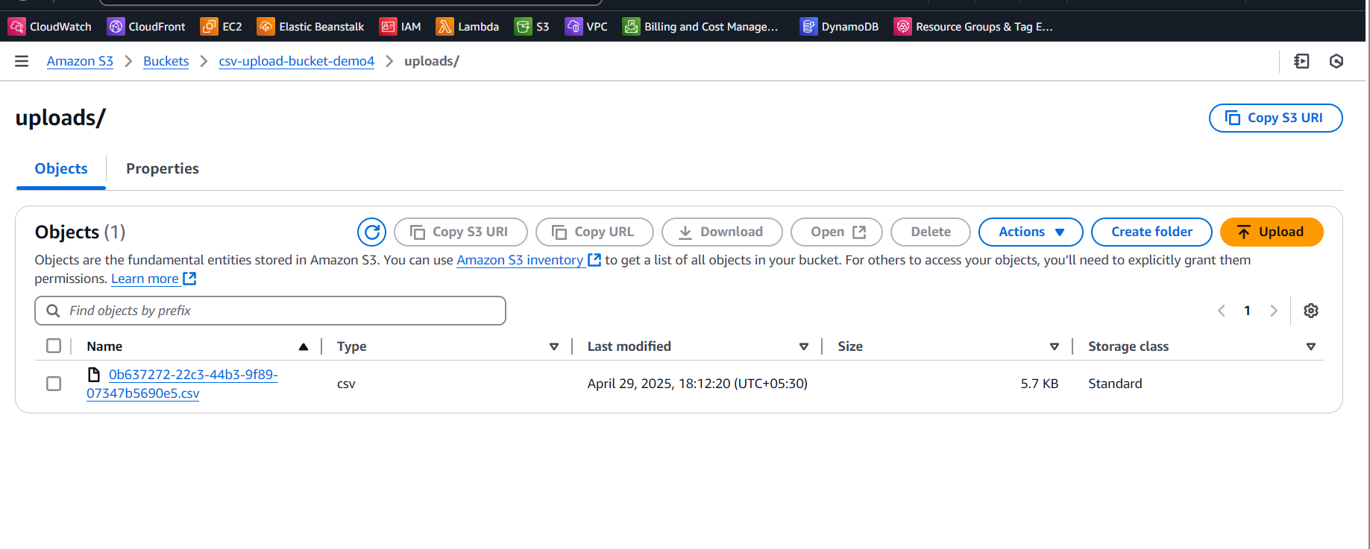

Then once the file get received my s3 trigger lambda function will get triggered in which my csv file content will parse and the data will get fetch into my dynamo db table

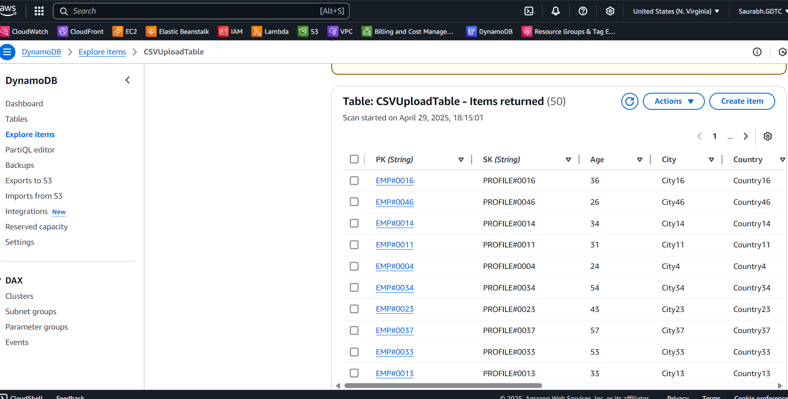

After the data get fetched in my Dynamo DB table it will send the message through queue where my third lambda function is integrated and when the message goes to queue it will trigger my third lambda function in which the logic is that delete the csv file that is uploaded after 120 secs  
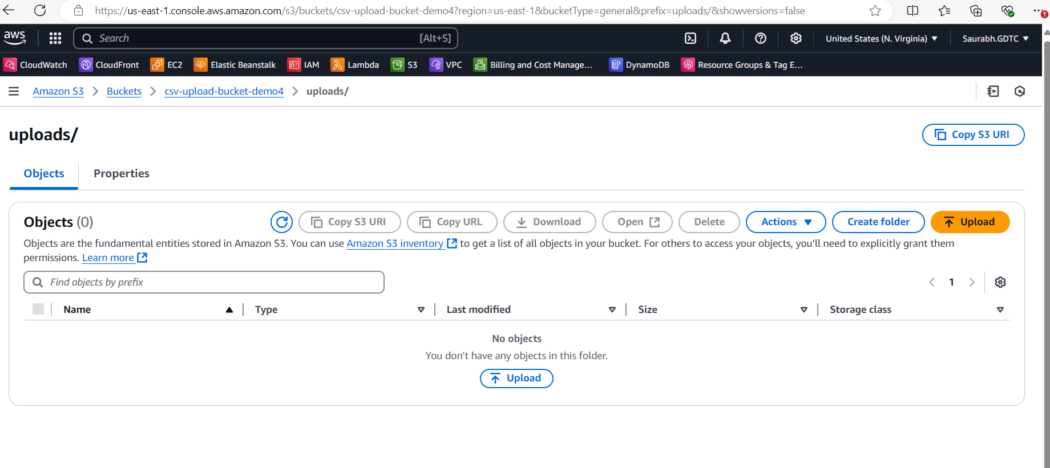

**Client → GET /details → API Gateway → Lambda → DynamoDB**

1. By using the get method the data should be retrieved from the Dynamo DB table

